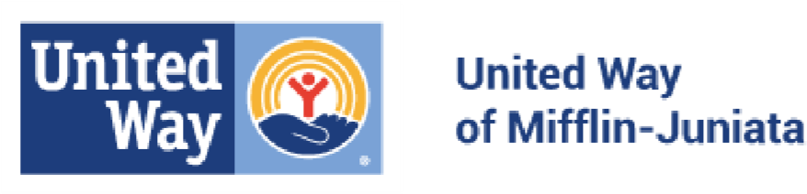
The organization must provide and meet ALL criteria in order to be considered for UWMJ funding. Number each attachment in top right corner of the front page and present the attachments in numerical order.

PARTNERSHIP ELIGIBILILITY CRITERIA

All applicants are required to provide all documentation regardless of being funded in previous years.
ATTACHMENT 1: Copy of Charter & By-Laws (only for new applicants)
ATTACHMENT 2: Copy of IRS Tax Exempt Letter (only for new applicants)
ATTACHMENT 3: Copy of Department of State Bureau of Charitable Organization-Commonwealth of PA
ATTACHMENT 4: Copy of Board Approved Budget for 2023-2024 funding cycle with minutes
ATTACHMENT 5: Current Board of Directors list, a meeting schedule, and attendance for the past 12 months. ATTACHMENT 6: Copy of Annual Report if applicable

Check the box next to each statement to confirm that your Organization meets the following criteria.
Agency complies with all federal, state, and local laws. There are no tax liens against the agency, no delinquent payroll taxes or other past due payments to government agencies. All licenses necessary to provide the agency’s programs and services are valid and in good standing.
The Board of Directors is the cornerstone of the organizational structure. The Board is responsible for all areas of the agency’s operation and it is the policy-making and resource allocating entity of the organization.
The agency (in the immediately preceding year) spent 25% or less of its total support and revenue on administration and fundraising expenses. (Computed from IRS form 990)
The agency provides services to all and prohibits discrimination and harassment of any type without regard to race, color, religion, age, sex, national origin, disability status, genetics, protected veteran status, sexual orientation, gender identity or expression, or any other characteristic protected by federal, state or local laws.

I certify that the above information is correct:
Signature:
Print:

Date:

