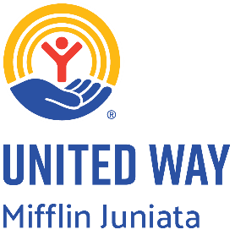
2023-24 Annual Report
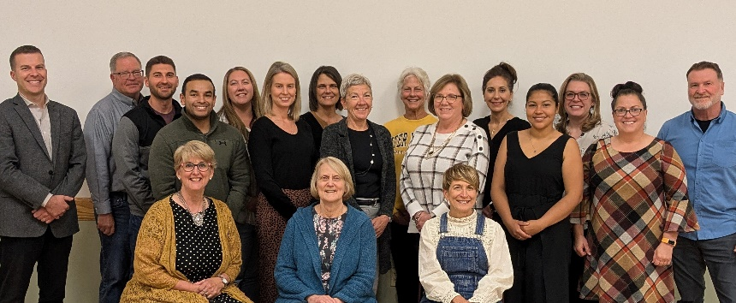
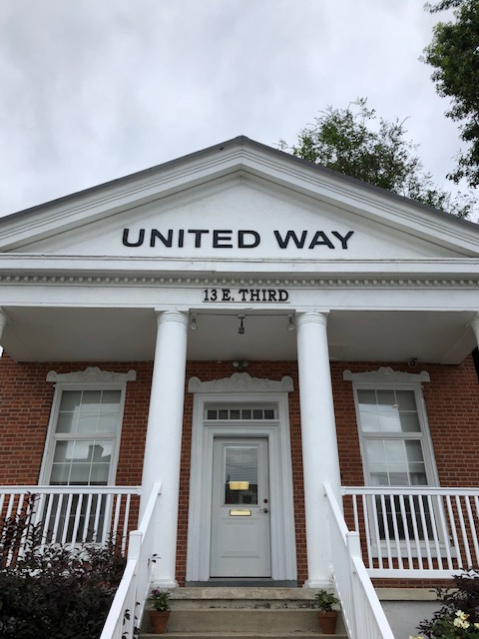
STATEMENT OF ACTIVITY
FOR THE FISCAL YEAR ENDED JUNE 30, 2024

CAMPAIGN & OTHER CONTRIBUTIONS $576,445

USE OF FUNDS
FUND DISTRIBUTION $ 228,300
COMMUNITY INITIATIVES $ 16,093
CONTRIBUTIONS TO ENDOWMENT $ 3,727
FUNDRAISING EXPENSE $ 41,962
OTHER DESIGNATED EXPENSE $ 22,371
PROGRAM SERVICES $ 258,284
MANAGEMENT & GENERAL EXPENSE $ 37,894

TOTAL $576,445



Officers
President: Candy Hoffman, Pennian Bank
Vice President: William Burmeister Geisinger Health System
Secretary: Mike Petroski, Retired, Standard Steel
Treasurer: Tyler Hess, Phoenix Physical Therapy
Asst. Treasurer: Corrinne Pierce, FOXPRO

Staff
Executive Director: Colette Hartzler
Resource Coordinator: Holly Dean
Clerical Support: Ruth Jones


Board of Directors
Christina Calkins-Mazur, Community Member
Jeff Davis, Attorney at Law Torquato Law office
Noah Wise, MC Commissioner
Rhonda Kelley, Juniata River Valley Chamber of Commerce
Ana Lopez, Realtor Jack Gaughen
Kristen Graybill-Above and Beyond Century 21
Jose Lopez, Controller Encompass Health
Ruth Fisher, Retired
N. Sue Reinke, Community Member
Jeff Moore, JC CYS
Lisa Snyder, JVB bank
Beth Gilmore, Kish Bank
Brett Rogers, Elder Turkey Farm
Monica Maxwell, Standard Steel

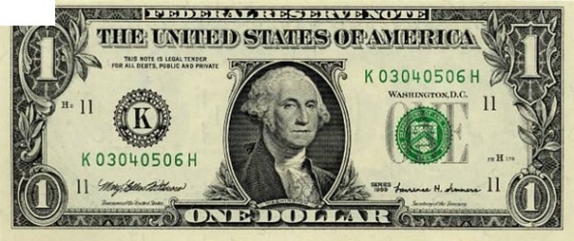
98% of all donations to United Way of Mifflin-Juniata stay in the local community!

How Do You Measure the True Value of United Way to the Community?

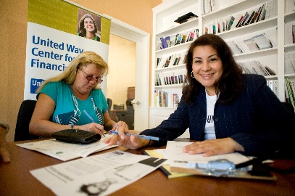
Community Investment
The United Way of Mifflin-Juniata prides itself on functioning with the utmost accountability and transparency to ensure that the generosity of our donors and grantors is utilized in the most effective and efficient way possible. THE UNITED WAY works hard to earn your TRUST and remains steadfastly committed to our role as faithful stewards of the hard-earned resources entrusted to us by the generous people of this community.

Each year volunteers donate time and talent to this process. During the 2023-2024 community investment process, 24 volunteers spent a total of 75 hours working on Community Investment. The dollar value of that time and talent based on the Independent Sector’s value of volunteer time equates to $2,385. Value to our community – PRICELESS!
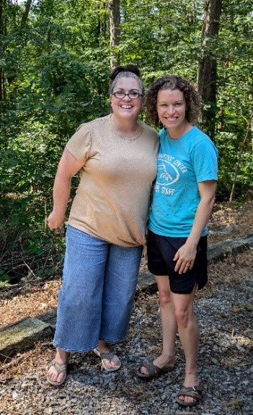
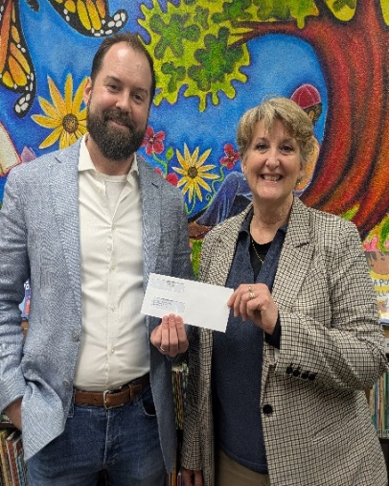
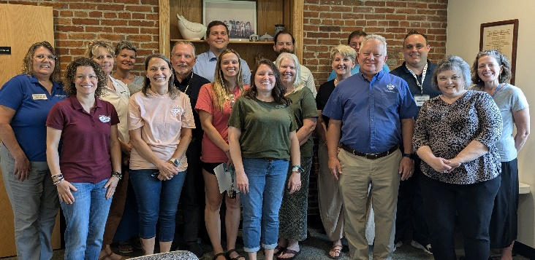

Your contributions went
to these Community Partners





Health
Education
Boy Scouts of America, JV Council
Community Partnerships RC&D
Crossroads Pregnancy Center
Compass Community Connections (Special Needs)
Juniata County Library
Mifflin County Library
Paul Delauter Youth Center
American Red Cross
Fayette Area Lion’s Den
LUMINA Center
NuVisions Center
Juniata Valley YMCA
Bob Perks Cancer Fund
$89,100.00

Income
$116,000.00
The Abuse Network
MidPenn Legal Services
United Way Initiatives
The Nurse’s Pantry - $10,000.00
M-J Energy Bank (November-March) $14,000.00

Christian Retreat Center
$37,800.00

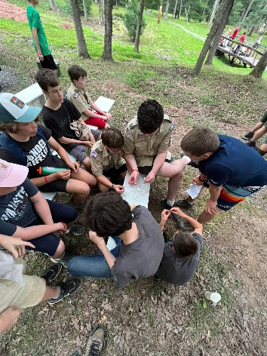
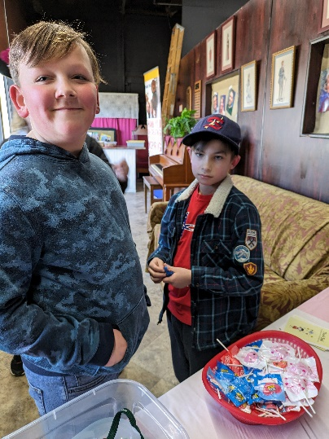
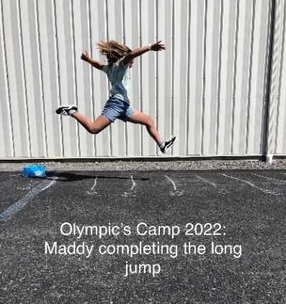


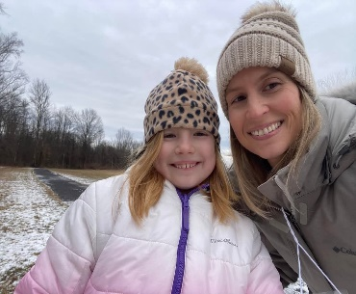
Day Of Caring

Our 27th Annual Day of Caring was held on Wednesday, September 18, 2024. Approximately 368 volunteers (45 teams) completed projects at 40 sites in Mifflin and Juniata Counties. Thank you for our community volunteers for coming together to complete projects in efforts of saving thousands of dollars for our local non-profits. We could not do it without you!
JACKHAMMER CLUB SPONSORS ($750)  - Alltrista  - First Quality  - Geisinger  - Juniata Valley Bank  - Encompass Health  - Standard Steel  - Lewistown Alliance Church | SLEDGEHAMMER CLUB SPONSORS ($500)  - Altiery Gingrich insurance agency  - Davita Dialysis  - Dietz Electric, LLC  - Everence Federal Credit Union  - JP Edwards  - Kish Bank  - Lowes  - MCS Bank  - Metzler Forest Products, LLC  - Pennian Bank  - Philips Ultrasound  - Sanitation Solutions Plus  - Sharp Shopper  - Susquehanna Fire Protection  - The Stewardship Group  - Trinity Plastics  - UGI Energy  - Zook’s Masonry | CARPENTER CLUB SPONSORS ($250)  - Blaise Alexander Subaru of Lewistown  - FOXPRO  - Lerch RV  - Clayton Homes  - Impress Design & Print

The Nurse’s Pantry: The Nurse’s Pantry is an initiative focused on elementary school students in both Juniata and Mifflin counties that have obstacles that prevent them from attending school. The lack of items such as clothing, shoes, and hygiene products including lice kits which may prevent children from attending school or cause them to be sent home from school. The Nurse’s Pantry is offered in two elementary schools in Juniata County as well as all elementary and intermediate schools in Mifflin County. During the 2023-2024 school year The Nurse’s Pantry helped 1056 elementary and middle school students in Mifflin County and assisted with purchasing items for 400 students in Juniata County.
The Mifflin Juniata Energy Bank: United Way of Mifflin-Juniata partners with the Mifflin-Juniata Human Services Department to offer the Mifflin-Juniata Energy Bank. The Mifflin-Juniata Energy Bank provides heat assistance to veterans, residents age 65 or older and families who have been denied Low Income Home Energy Assistance Program (LIHEAP) benefits due to income ineligibility or rent assistance to those qualified. Every year the United Way of Mifflin-Juniat hosts the Walk for Warmth, the only fundraiser for the Mifflin-Juniata Energy Bank. The 13th Annual Walk for Warmth was held this February and raised, along with other donations from the community $14,581.50 for the Mifflin-Juniata
From November 2023 through March, 2024 the Mifflin-Juniata Energy Bank Provided heating or energy assistance, totalling 14,052.12
We served 39 total families in Mifflin County and in Juniata County

Community Initiatives 2023-2024
The United Way of Mifflin-Juniata’s 2024 campaign raised a total of $373,160.00. Below are the top ten employee and corporate campaign contributors. In each row, the top number represents the employee contribution, and the bottom amount represents the corporate contribution.

TITLE

2024 Campaign Raised 373,160
Thank you to our top employee/corporate campaign fundraisers!

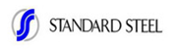
$22,631
$16,957


$12,154
$13,800

$15,562
$10,000


$23,462
$750


$7,255
$1000

$7,088

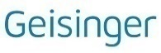
$4,994
$750
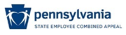
$5,710

PA Association of School
Retirees, MC Chapter $8,395

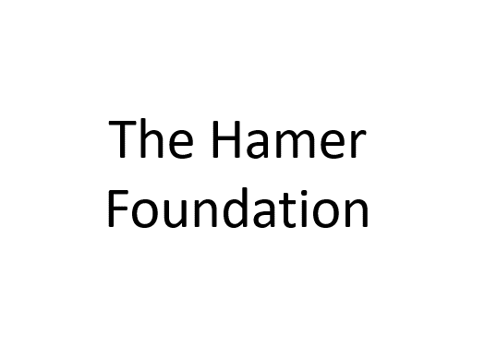
$30,000

The United Way of Mifflin-Juniata would like to thank everyone who contributed to the 2024 Campaign. Leader’s Circle represents a different level of community participation, an indication of deeper involvement and a desire to do more. With a contribution of $500 or more Leaders’ Circle members strengthen the United Way and significantly increase its ability to provide needed local human services.
In 2024 Leaders’ Circle giving represented 31% of the campaign. Once again, a special thanks goes to all the leadership givers and all others who participated in the 2024 campaign.

The Leader’s Circle

Alexis de Tocqueville - $10,000 & Above
Anonymous

Diamond Circle –
$5,000 - $9,999
Anonymous
James Fulkroad, Sr
Anita Rudy

Platinum Circle –
$3,000 to $5000
Marcie A Barber
John B. Eby II
Ed & Nancy Lerch

Gold Plus Circle –
$2,000 to $2,999
Helen S Macklin
Helen L. Montgomery
Jim & Patti Shilling
Carol Ann Spendiff
Glenn & Lisa Snyder

Gold Circle –
$1,500 to $1,999
Anonymous (2)
Charles W. Everhart
William & Sandra Gomes
John Harwood
William P. Hayes
Laura Lettiere
Carol Lockard
Helen Lodanosky
Larry & Patricia Niemond
Neil A. Purcell
Daniel & Beth Reifsnyder

Silver Circle –
$1,000 to $1,499
Anonymous (2)
Marcie A Barber
Rebecca Blasi
Susan Chapman
Jacqueline Eckert
Delmer Guerrini
Reid Hannon
Todd A. Kearns
Kenneth & Laura Litwiller
Bruce & Barbara Nielsen
Charles Phillips
Freda Richard
Michael Rowe
Dorothy Rudy
Ronald E. Thomas
Ann M. Thompson
Joseph Westover
Mark Zong

Bronze Plus Circle –
$750 to $999
Anonymous (2)
Jerad M. Esh
Michael E McCurdy
Michael Petroski
Timothy & Susan Searer
Ed & Diane Stewart
Thomas Wolf
Karen Zimmerman

Bronze Circle –
$500 to $749 Anonymous (13)
Phillip P. Bailey
Douglas S. Barber
Shirley M Baxter
James JP. Bricker
Daniel Brown
Kim Bubb
Michael Buffington
Richard D. Crider
Steven & Oksana DeArment
Martin & Kimberly Dreibelbis
Steven E Dupert
James O. Egolf III
Kenneth P. Fisher
Terry L. Foster
Eric K. Fowler
Shannon L Gingerich
Larry & Judith Gisewhite
Paul Grego
Bryan Hale
James F. Havice Jr.
Ashley Henry
Alfred Hughes
James & Phyllis Johnson
Richard & Maryann Keefer
Ryan Keefer
Todd Kipp
Marie C. Kirkpatrick
Tina M Kise
Brian Knepp
Kraig J Kratzer
William Lake
Jason & Liz Lightfoot
Carole J. Mast
Thomas E. McNabb
Alyssa Middaugh
Stacy Moist
Kristie Musselman
Tracey Peters
Barry Paterson
Andy & Angie Pollock
Marvin Reinke
Robert & Susan Richard
Aaron Rogers
Darwin Shawver
Mary Lou M Sigler
Tina J. Smith
Jan Snedeker
Alton Stake
Jim & Nanette Stake
Lindsey Swigart
Cheryl Swineford
Richard VanHorne
David & Patricia Walker
Robert Watts Jr.
Barry D Weaver
Thomas D Weldon
Jeff Wilson
Samantha Wolfley

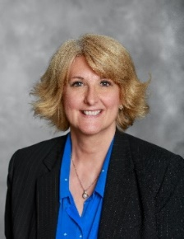

A Note from the Executive Director
What an incredible year it's been for the United Way of Mifflin-Juniata! In 2024, the generosity of our community allowed us to create a significant impact throughout Mifflin and Juniata Counties. We're thrilled to share some of the standout moments and achievements from the past year.

Community Events and Collaborative Successes
Our third annual golf tournament was a fantastic success, even with the drenching rain! Our dedicated golfers braved the weather, played with enthusiasm, and showed incredible support for our mission. Their spirit truly embodied the resilience of our community.
We were also proud to be a part of the Communities that Care and Hope Collective AFTER PROM PARTY in Mifflin County. Hosted at the YMCA, this vital event provided a safe and engaging environment for teens after prom, offering a wide array of activities and an abundance of food. It's a wonderful example of how collaboration can keep our young people safe and protected.

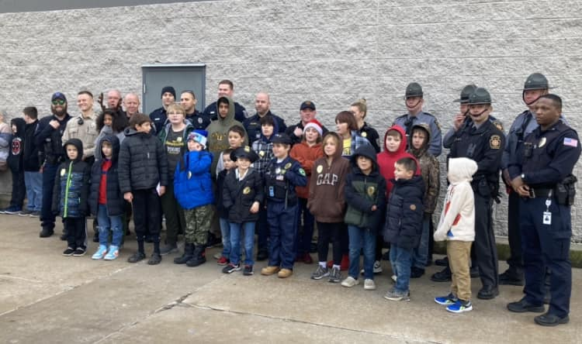
Shining Examples of Giving Back
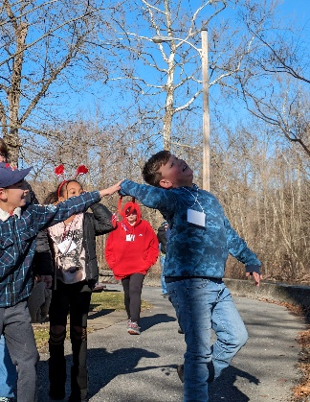
The Shop with a Cop event was a truly heartwarming initiative and a shining example of our impactful partnership with the PA State Police. Thanks to our fundraising efforts, we were able to provide 24 at-risk children and young teens with the unique opportunity to go Christmas shopping alongside a State Trooper or County police officer. The joy on the children's faces, mirrored by the officers, made it a truly special day for everyone involved. Following the shopping spree, families enjoyed a pizza party and a visit from Santa, with children having the option to have their gifts wrapped. The "Season of Giving" truly came alive that day.
We also organized and raised funds for the Walk for Warmth for the Mifflin-Juniata Energy Bank, a vital collaboration with Mifflin-Juniata Human Services. The 2024 Walk was a sunny and cool day at Kish Park, where walkers turned out in force to support those in our community struggling with rising fuel costs. Their willingness to walk through the cold embodied the warmth of community support.
And, of course, our annual Day of Caring brought volunteer power to nonprofit agencies across Mifflin and Juniata Counties. This amazing day sees individuals and companies standing side-by-side with local organizations, lending a helping hand where it's needed most.

Looking Ahead: A New Chapter and Renewed Commitment
We are thrilled to report that we reached over 85% of our fundraising goal for the year! In a time of rising prices and increasing struggles for families, the caring power of our community truly amazed us.
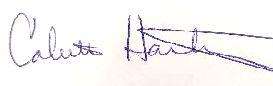

As 2024 drew to a close, we also prepared for an exciting evolution in our brand, guided by United Way Worldwide. Our beloved tagline, LIVE UNITED, has now become a part of our rich history. Leading the charge into the future is our vibrant new tagline: UNITED IS THE WAY. This new message, along with an updated color palette, is all part of our commitment to remain viable and visible in our community. As we looked ahead to our 90th anniversary in January, we knew we were ready to move forward and go 90 more! UNITED IS THE WAY—we move forward.
Kind Regards,
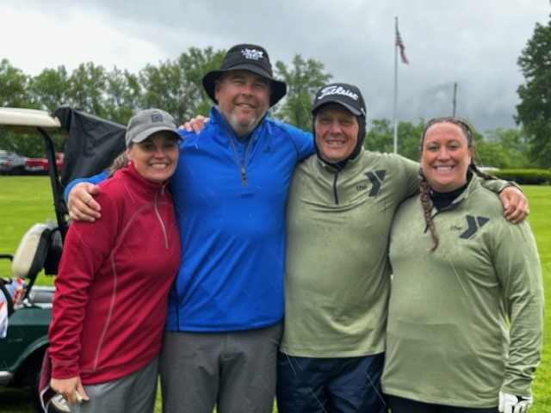
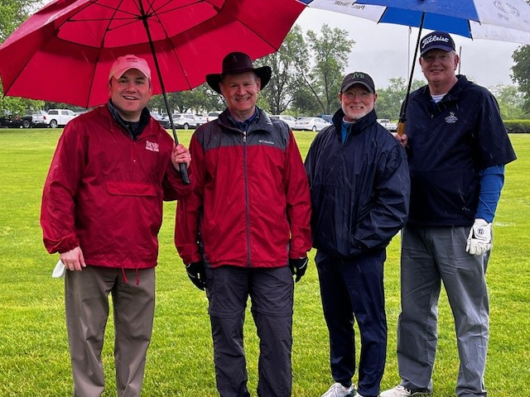
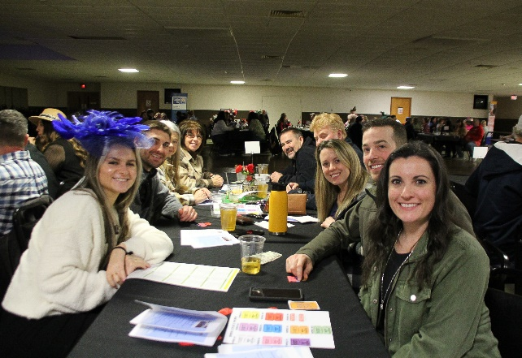
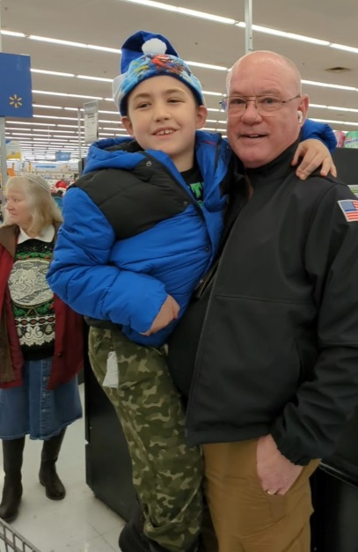
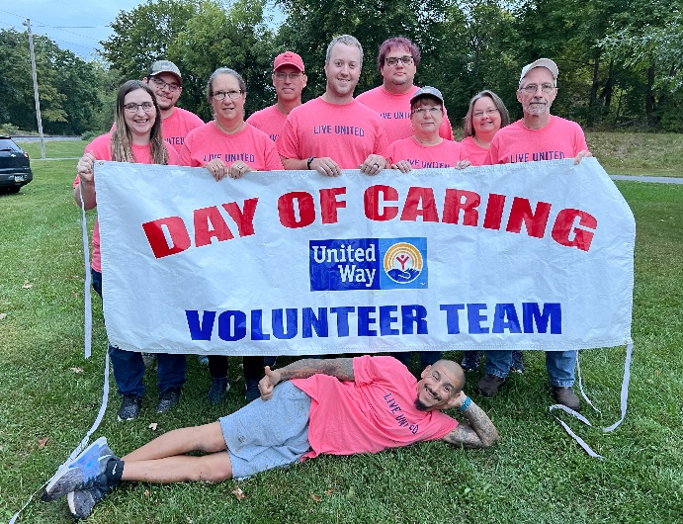
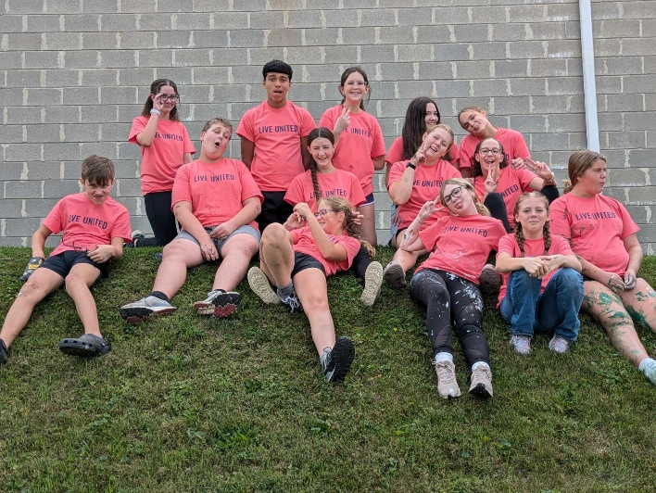
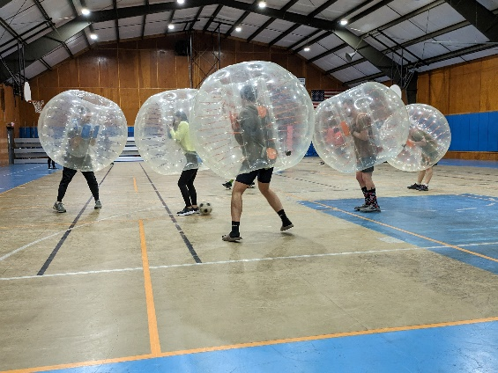
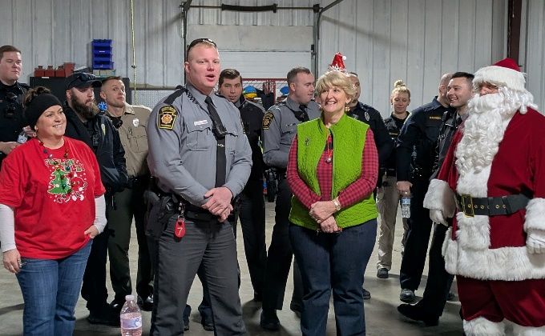

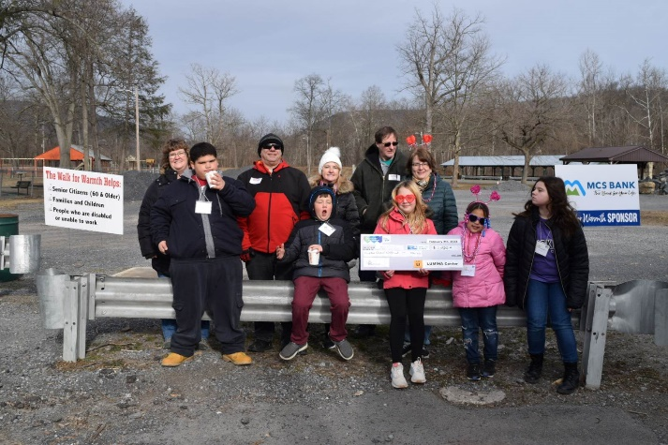
Thank you for a
Wonderful 2023-2024
Campaign year!

