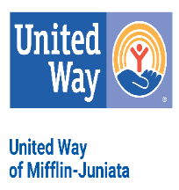

**2025 MIFFLIN-JUNIATA COUNTY GOLF UNITED CLASSIC**

**SPONSORSHIP REGISTRATION**

**Company Name: _______________________________________________________**

**Contact Person: ________________________________________________________**

**Address: ______________________________________________________________**

**Phone: ________________________________Email: __________________________**

* **PLATINUM/TOURNAMENT TITLE SPONSOR $5,000**
* **ACE SPONSOR $2,500**
* **PAR LUNCH SPONSOR $2,500**
* **EAGLE SPONSOR $1,000**
* **HOLE-IN-ONE SPONSOR $ 450**
* **HOLE SPONSOR $ 120**
* **DONATION TO UNITED WAY OF MIFFLIN-JUNIATA $ _**

**TOTAL: $**

**Payment:**

* **My check is enclosed**
* **Please invoice me**

**If we do not have an updated company logo, please email a PDG or JPEG of the logo to** [**chartzler@mjunitedway.org**](mailto:chartzler@mjunitedway.org)**. Thank you for your support!**

**Please return to: United Way of Mifflin-Juniata, 13 E Third St, Lewistown PA 17044**